CaseManagement_TestForCaseEscalation_Instance29_26-Jul-2018_08-34-04_AM_GetTextFromElement.png

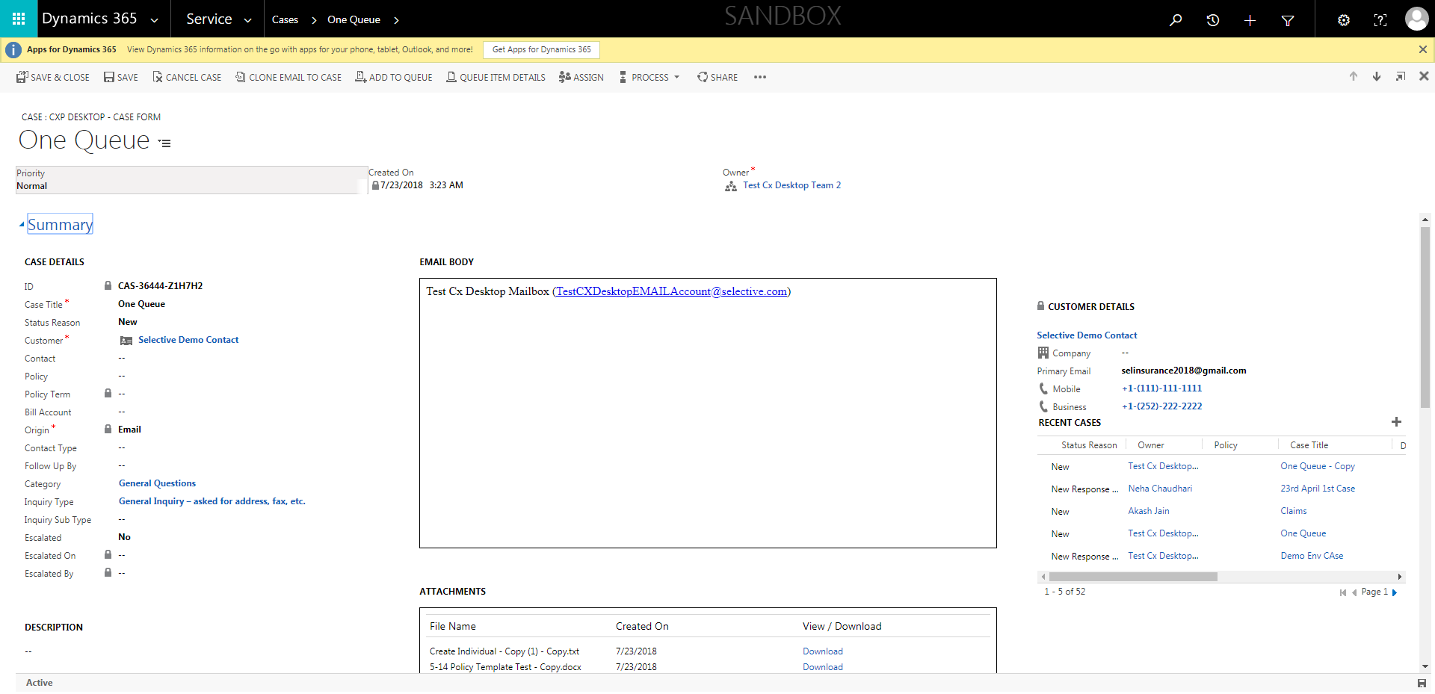

CaseManagement_TestForCaseEscalation_Instance29_26-Jul-2018_08-34-04_AM_ValidatingpresenceofEscalatedByField.png

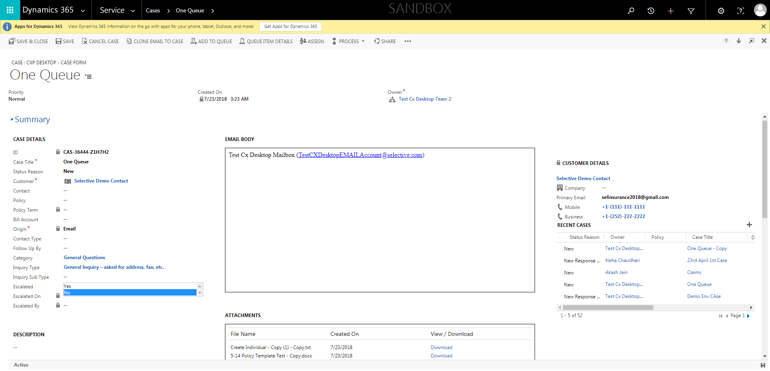

CaseManagement_TestForCaseEscalation_Instance29_26-Jul-2018_08-34-10_AM_ValidatingCaseOwnerChangesafterEscalatingCase.png

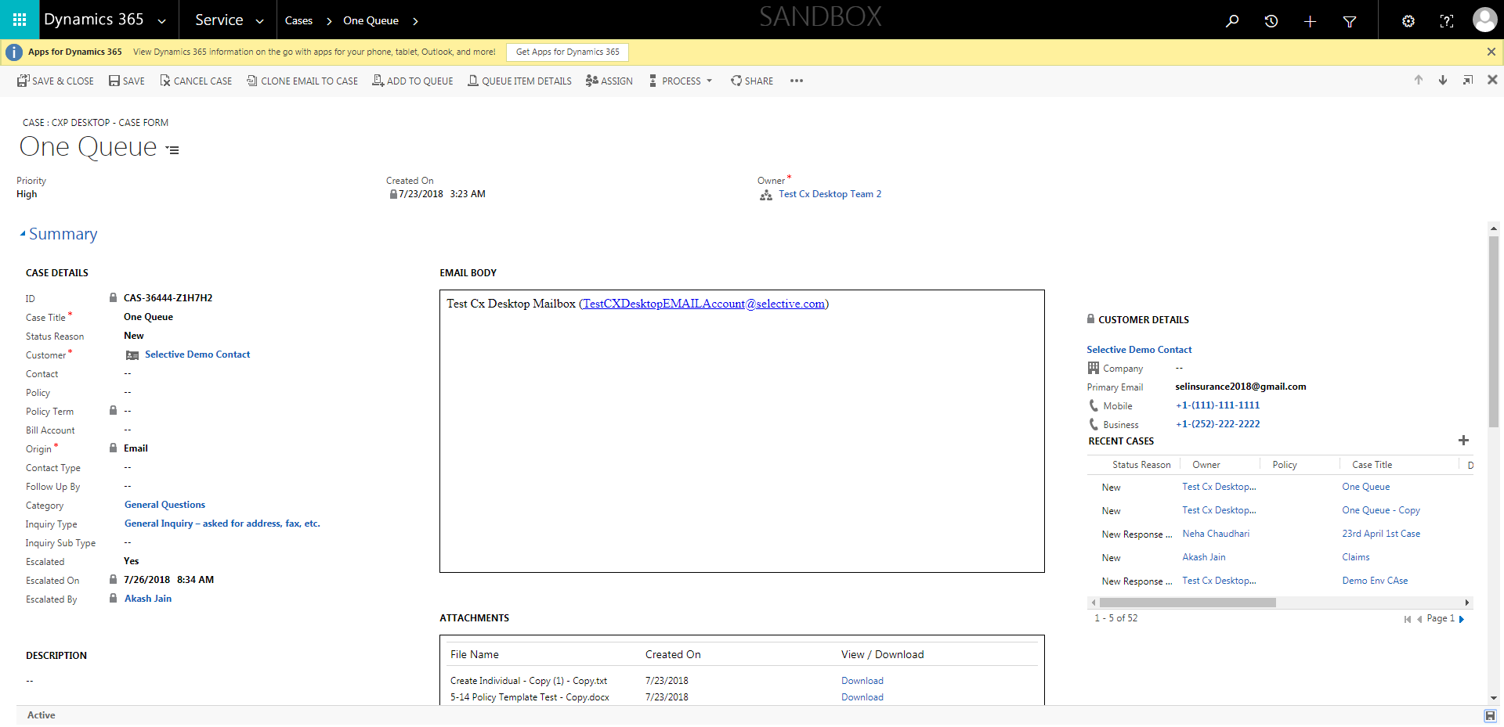

CaseManagement_TestForCaseEscalation_Instance29_26-Jul-2018_08-31-38_AM_SingleSignOn.png

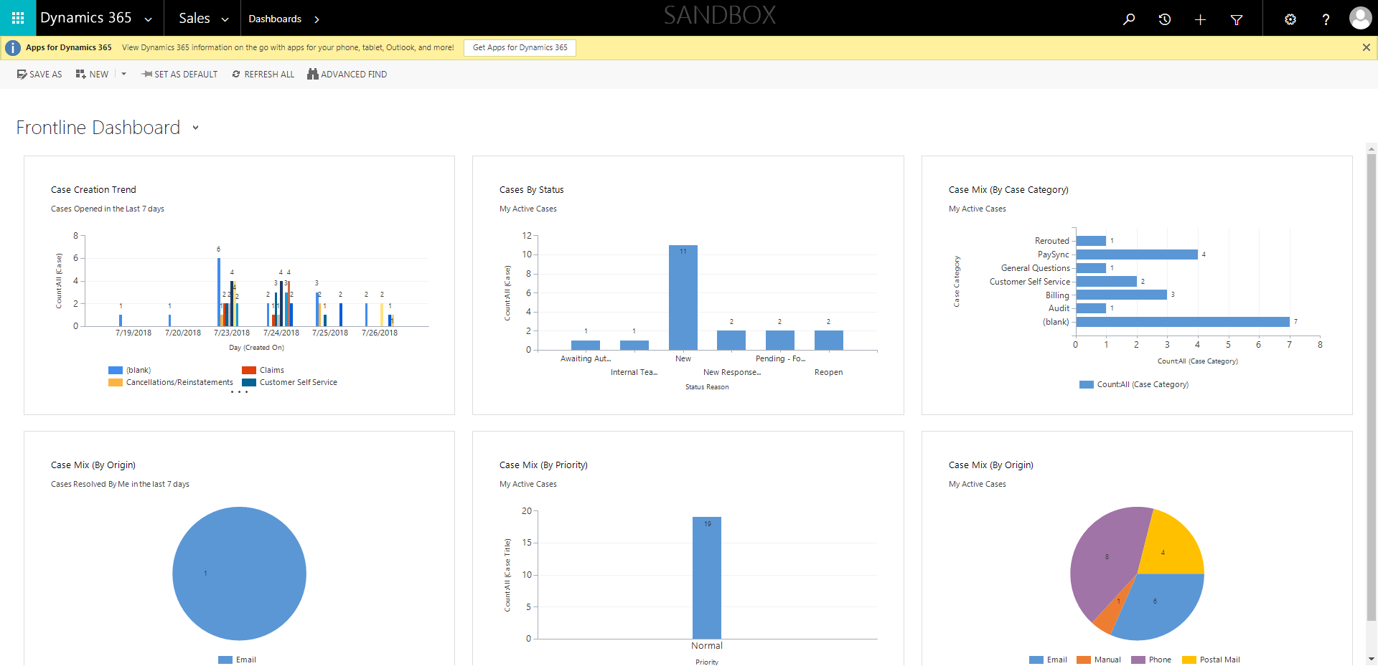

CaseManagement_TestForCaseEscalation_Instance29_26-Jul-2018_08-35-04_AM_ValidatingDeEsclationofcasebyFLEuser.png

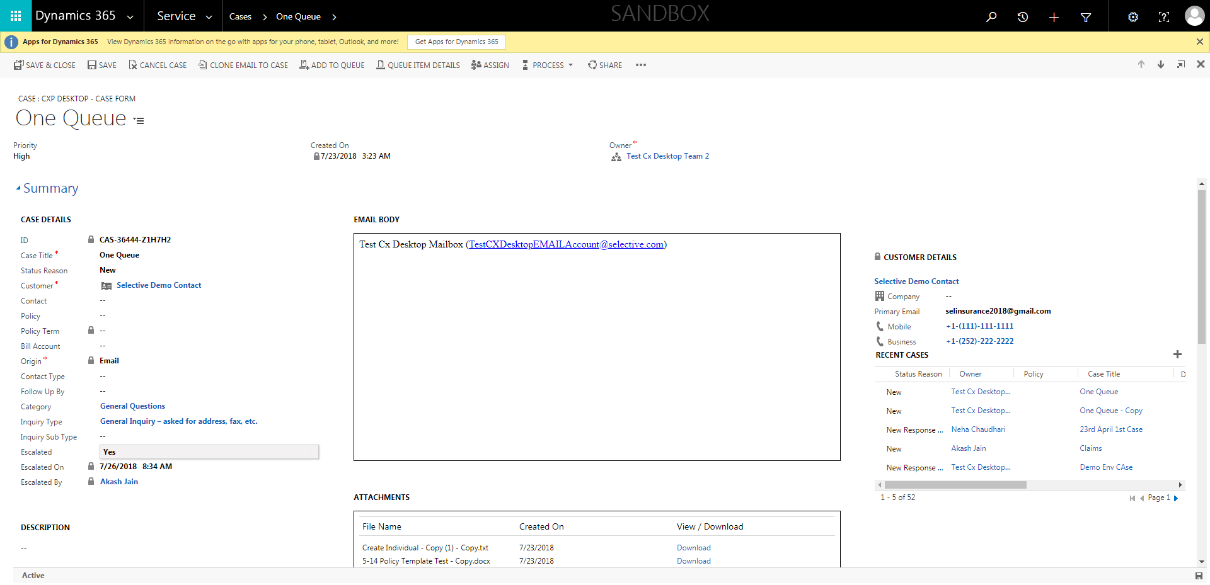

CaseManagement_TestForCaseEscalation_Instance29_26-Jul-2018_08-33-06_AM_ValidatingCaseentitynavigation.png

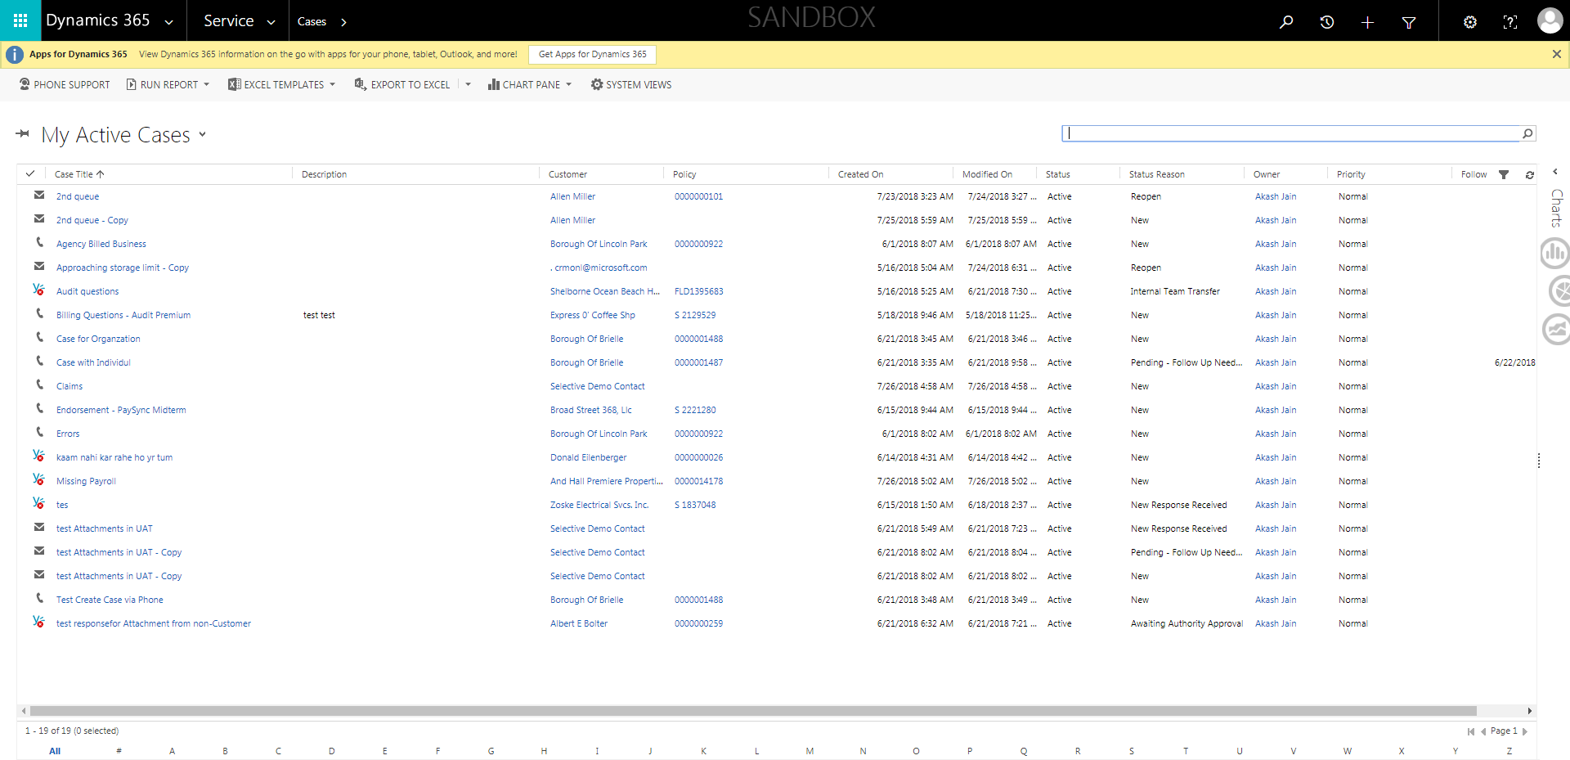

CaseManagement_TestForCaseEscalation_Instance29_26-Jul-2018_08-34-03_AM_ValidatingpresenceofReadonlyEscalatedByField.png



CaseManagement_TestForCaseEscalation_Instance29_26-Jul-2018_08-34-09_AM_ValidatingCaseEscalatedChanges.png



CaseManagement_TestForCaseEscalation_Instance29_26-Jul-2018_08-31-18_AM_MouseClickActiononStaleElement.png



CaseManagement_TestForCaseEscalation_Instance29_26-Jul-2018_08-31-16_AM_EnterTextAction.png



CaseManagement_TestForCaseEscalation_Instance29_26-Jul-2018_08-31-14_AM_MouseClickActiononStaleElement.png

